Centrifuge for Microplates—MPC2800
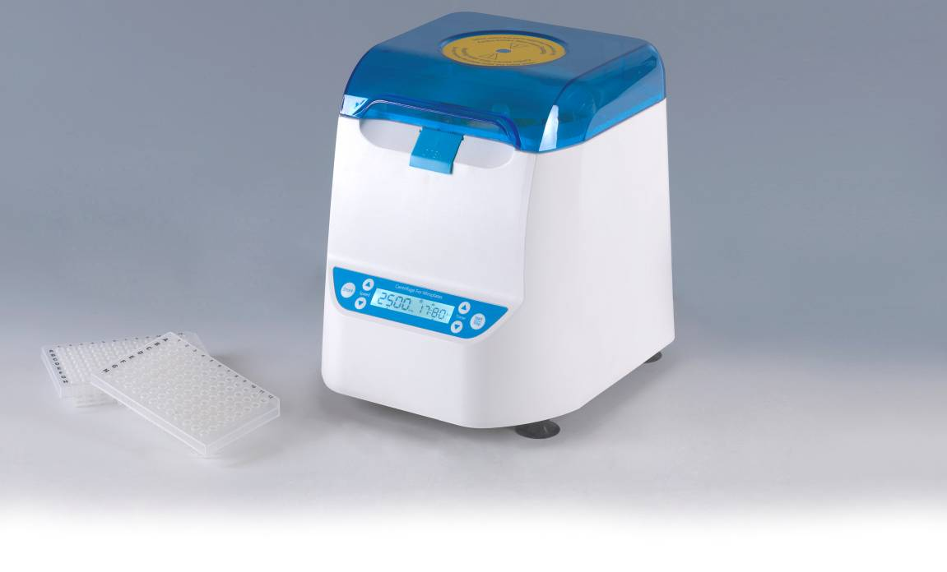

Introduction
MPC2800 Centrifuge for Microplates is designed for quick spins of samples in PCR plates. Primarily designed for use with 96 or 384 well plates and small volumes, it will accommodate skirted, non skirted and semi skirted styles.

Features:
- Easy to use, real-time display of all operating information.
- Countdown mode support.
- DC brushless motor, low noise, small interference, maintenance-free.
- When opening the cap will automatically stop running.
- Fast acceleration from standstill to maximum speed fully in just 10sec.
- Braking time is short, from the highest speed to a complete standstill in just 4 sec.

Parameters
Model | MPC2800
Rotating speed | 2200~2800rpm
Timing range | 15sec ~1min59sec
Max(RCF) | 550g
Acceleration time | ≤10sec(from 0 to 2800rpm)
Brake time | ≤4sec(from 2800rpm to 0)
Lid Open Auto Stop | Yes
Short run | Yes
Capacity | 2 PCR plates
Power | 45W
Voltage | AC100~240V/50-60Hz
Fuse | 250V/3A Ф5×20
Dimension(mm) | 260x240x226
Weight(kg) | 3.3

